ADIDAS SALES PERFORMANCE ANALYSIS
Project Documentation
1. Introduction
This project focuses on analyzing Adidas sales performance across multiple regions, retailers, product categories, and sales channels using Microsoft Excel. The aim is to transform raw transactional sales data into meaningful insights that support strategic decision-making. By leveraging data cleaning techniques, pivot tables, and dashboard visualization, the analysis provides a clear understanding of revenue drivers, profitability, and customer purchasing behavior.
2. Business Context
Adidas operates through multiple retail partners, including Foot Locker, Walmart, and Sports Direct, and distributes products through various sales channels such as in-store, outlet, and online platforms. While large volumes of sales data are collected, the data had not been fully utilized to identify trends, performance gaps, or optimization opportunities. This project addresses that challenge by organizing and analyzing the data to uncover actionable insights.
3. Problem Statement
Despite consistent sales activity across different markets, Adidas faces challenges in identifying which product categories and retailers drive the most revenue and profit, understanding how customer behavior differs across sales channels and regions, recognizing underperforming markets or product lines, and optimizing marketing campaigns, pricing strategies, and inventory allocation using reliable data.
4. Project Objectives
The objectives of this analysis are to:
- Measure overall sales and profitability performance during the analysis period
- Identify top-performing and underperforming product categories, regions, and sales channels
- Compare sales contributions of major retail partners
- Assess the effectiveness of different sales methods
- Generate data-driven recommendations to support future sales and marketing strategies
5. Dataset Overview
The dataset consists of Adidas sales transaction records and includes the following key attributes:
- Retailer name and retailer ID
- Invoice date
- Region, state, and city
- Product description
- Price per unit and units sold
- Total sales
- Operating margin
- Operating profit
- Sales method (in-store, outlet, online)
The dataset supports analysis across time, geography, product lines, and sales channels.
6. Data Cleaning and Preparation
Before analysis, the dataset underwent thorough cleaning and preparation to ensure accuracy and consistency.
6.1 Validation of Financial Metrics
An initial review revealed inconsistencies in the Total Sales and Operating Profit columns. These values were recalculated to correct errors and ensure accurate financial reporting.
- Total Sales was recalculated as:
Price per Unit × Units Sold
- Operating Profit was recalculated as:
Total Sales × Operating Margin
6.2 Date Transformation
The invoice date column was separated into additional time-based fields:
- Year
- Month
- Weekday
This enabled trend analysis across monthly, yearly, and weekday timeframes.
6.3 Product Categorization
Product descriptions were standardized and split into a new Product Category column (e.g., Footwear, Apparel). This improved the accuracy of category-level comparisons and reporting.
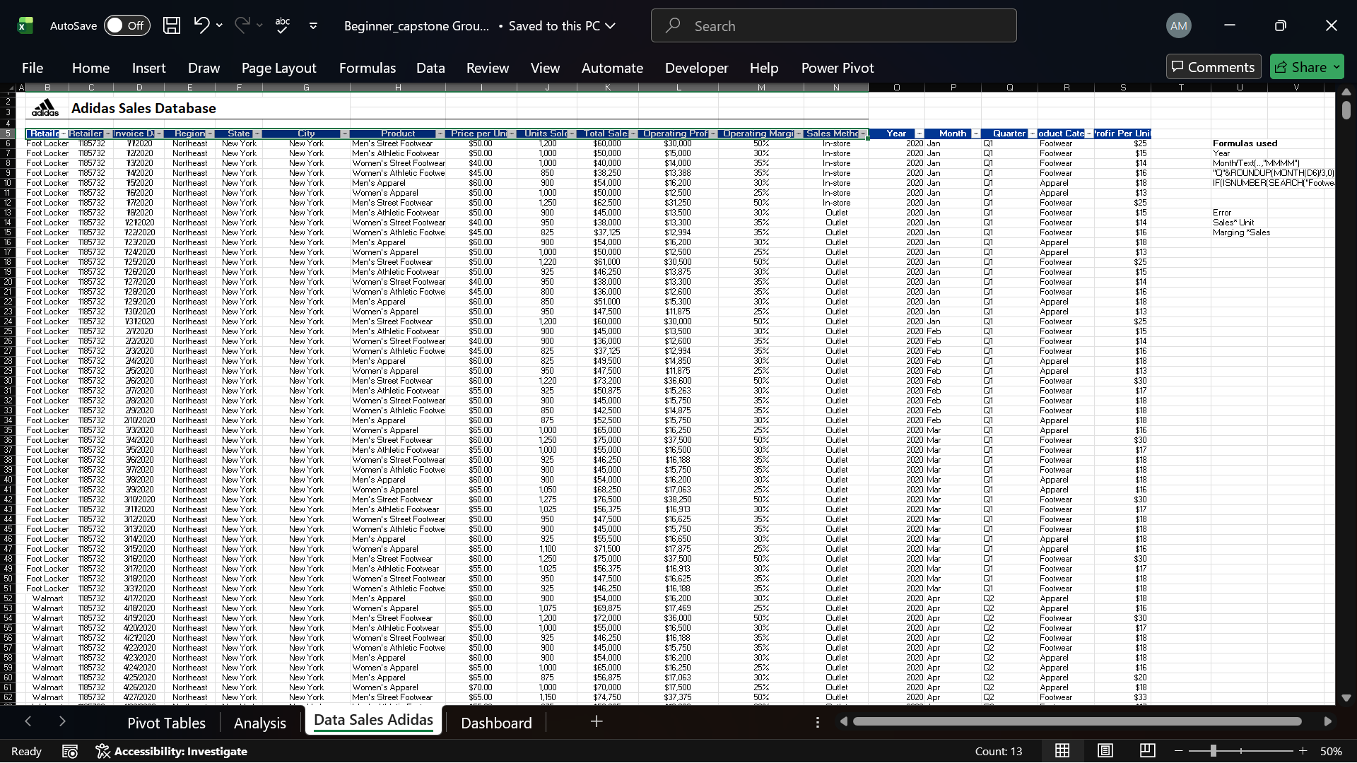
6.4 Data Consistency Checks
Additional checks were performed to ensure:
- Uniform naming of regions and retailers
- Consistent formatting of sales methods
- Removal of duplicate or inconsistent values
After cleaning, the dataset was confirmed to be accurate and analysis-ready.
7. Methodology
7.1 Tools Used
- Microsoft Excel
- Pivot Tables
- Pivot Charts
- Slicers
- Excel Dashboard Design
7.2 Analytical Approach
The analysis followed a structured approach:
- Data cleaning and transformation
- KPI calculation
- Pivot table creation
- Visualization development
- Insight interpretation
8. Key Performance Indicators (KPIs)
The following KPIs were used to evaluate performance:
- Total Sales
- Operating Profit
- Operating Margin (%)
- Units Sold
- Sales by Product Category
- Sales by Region
- Sales by Retailer
- Sales by Sales Method
These KPIs provided a holistic view of Adidas’ financial and operational performance.
9. Pivot Table Development
Multiple pivot tables were created to support analysis, including:
- Sales by Product Category
- Sales by Region
- Sales by Retailer
- Sales by Sales Method
- Monthly Sales Trend
- Product Line Across Regions
- Profit by Region
- Sales by State
Each pivot table was validated to ensure totals matched recalculated financial values.
10. Dashboard Design and Development
10.1 Dashboard Purpose
The dashboard was designed to present complex data in a simple, interactive, and visually appealing format for decision-makers.
10.2 Dashboard Components
The dashboard includes:
- KPI cards for Total Sales, Operating Profit, Operating Margin, and Average Units Sold
- Monthly sales trend chart
- Product line performance across regions
- Sales by product category donut chart
- Profit by region bar chart
- Sales by retailer bar chart
- Revenue by sales method
- Geographic sales visualization by state
10.3 Interactivity
Slicers were added to allow users to filter data by:
- Quarter
- Region
- Sales method
- Product category
This enables dynamic exploration of the data.
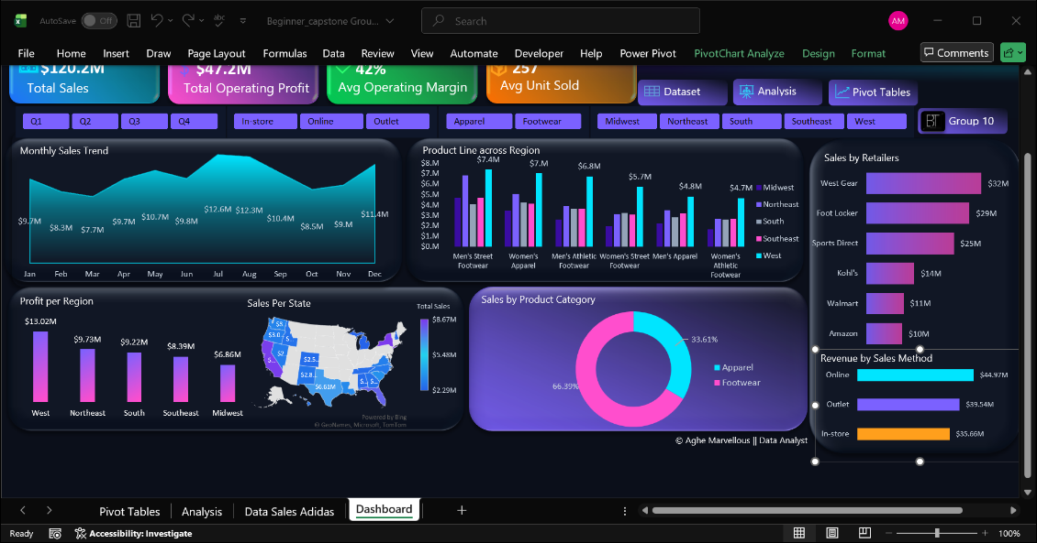
11. Key Insights Summary
- Footwear is the highest revenue-generating product category
- The West region consistently outperforms other regions in sales and profit
- Online sales channels generate the highest revenue
- A small number of retailers contribute a significant share of total sales
- Some regions and product lines underperform and require targeted strategies
12. Business Implications
The findings highlight opportunities for Adidas to:
- Strengthen profitable product lines
- Optimize channel strategies toward digital platforms
- Apply region-specific marketing and pricing approaches
- Improve inventory planning using demand patterns
- Reduce dependency on a limited number of retail partners
13. Recommendations
Product Strategy
Focus on expanding footwear offerings while optimizing underperforming apparel lines.
Channel Optimization
Prioritize online sales growth while maintaining outlet and in-store efficiency.
Regional Focus
Increase investment in high-performing regions and develop targeted strategies for weaker markets.
Demand Forecasting
Use historical trends to improve inventory and production planning.
Retailer and Partner Management
Strengthen partnerships with top-performing retailers and reassess strategies with lower-performing partners.
14. Conclusion
This project demonstrates how structured data analysis and visualization can transform raw sales data into actionable insights. By cleaning the data, applying analytical techniques, and developing an interactive dashboard, the project provides Adidas with a clear understanding of performance drivers and strategic opportunities. The insights and recommendations generated can support informed decision-making, improved profitability, and sustainable business growth.

